EIT SKILLING PROGRAMMES TRAIN 880 000 LEARNERS

Budapest, 6 November 2024 - The European Institute of Innovation & Technology (EIT), as part of Horizon Europe, is the only EU innovation instrument dedicated to integrating education and skills with research and business. By building long-term partnerships called, EIT Knowledge and Innovation Communities (KICs) between business, education, and research, the EIT has been able to amass a large portfolio of industry-focused skilling programmes that have trained over 880 000 learners.
Stefan Dobrev, Chairman of the EIT Governing Board, added: ‘There is no innovation without education. The EIT has proven that with the scale and power of its network, it is strongly contributing to closing the skills gap in Europe and ensuring that Europe has the talent pool necessary to remain competitive. We are committed to shaping the future of Europe’s innovation landscape and equipping a new generation with the skills to lead in cutting-edge technologies."

EIT EDUCATION: TRAINING THE TALENT OF TOMORROW

Thanks to strong connections between businesses and universities, the EIT Community has created and customised skilling and training programmes that directly respond to market demands. As part of the European Commission’s New European Innovation Agenda, the EIT has deployed new and existing training programmes to rapidly foster, attract and retain skilled workers in Europe, including launching the EIT Deep Tech Talent Initiative to skill one million learners.

The EIT is pleased to announce that, together with its pledging community, the EIT Deep Tech Talent Initiative has successfully targeted one million learners and trained 524 000 learners.

In addition, EIT skilling programmes have successfully targeted skills development at all levels of education including:
- training 64 758 secondary school students through the EIT Girls Go Circular project, committed to help young girls develop tech and entrepreneurship skills related to the green and digital transition.
- training 6 471 university students through the EIT Label with over 60 graduate degree programmes developed with 200 universities active in the EIT network.
- training and upskilling over 209 771, workers and professional learners through a wide variety of non-degree courses and workshops accessible online through the EIT Campus. Professional learners and workers have also been able to benefit from the targeted skills development programmes including the European Battery Alliance Academy and the European Solar Academy working with EU Member States and industry partners under the Net Zeros Industry Act to train and upskill workers in industrial supply chains.
- Training 69 000 students and faculty at Higher Education Institutions (HEIs) through the EIT HEI Initiative helping faculties build the capacity to teach innovation and entrepreneurship. During the programme’s pilot phase, 359 HEIs and 179 non-academic organisations were supported with EUR 69 million. Across 65 projects, more than 69 000 students, academic staff, and non-academic staff received training in innovation and entrepreneurship and over 1 000 start-ups and scale-ups benefitted from targeted support.

Most recently, the European Institute of Innovation and Technology (EIT) was recognised for its distinct education programmes being highly relevance to tackle the shortage of skilled workers in the high-tech sectors in the EU. As documented in the European Commission’s Directorate-General for Research and Innovation Horizon Europe Evaluation Study of Pillar 3, ‘EIT education activities foster innovation and entrepreneurship through purposeful education and training offered to students and professionals through high-quality curricula based on innovation, creativity, and entrepreneurship in line with the Union's industrial and skills strategy.’

EIT educational activities are designed to complement formal education in EU Member-States, offering a wide variety of specialised and vocational training. In addition, EIT programmes aim to increase the number of women in the traditionally male-dominated STEM sector – an essential goal for a gender equal and diverse Europe.

EIT - MAKING INNOVaTION HAPPEN!

About THE EUROPEAN INSTITUTE OF INNOVATION AND TECHNOLOGY (EIT)

The EIT strengthens Europe’s ability to innovate by powering solutions to pressing global challenges and by nurturing entrepreneurial talent to create sustainable growth and skilled jobs in Europe. The EIT is an EU body and an integral part of Horizon Europe, the EU Framework Programme for Research and Innovation.

The Institute supports dynamic pan-European partnerships, EIT Knowledge and Innovation Communities, among leading companies, research labs and universities. Currently nine EIT Knowledge & Innovation Communities are supported: EIT Climate-KIC, EIT Digital, EIT InnoEnergy, EIT Health, EIT RawMaterials, EIT Food, EIT Manufacturing, EIT Urban Mobility and the newest addition: EIT Culture & Creativity). Together with their leading partners, the EIT Community offers a wide range of innovation and entrepreneurship activities across Europe: entrepreneurial education courses, business creation and acceleration services and innovation driven research projects.
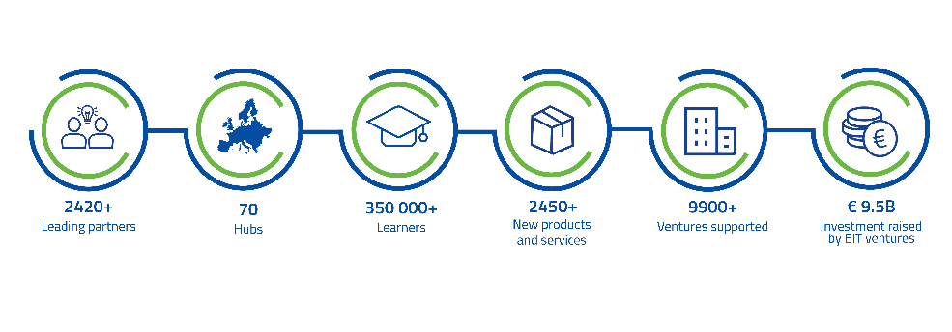

Stay TUNED FOR EIT WATER

The EIT continues to grow with its tenth Knowledge and Innovation Community (KIC) in the field of water, marine and maritime sectors and ecosystems. The new EIT KIC will drive innovation to tackle pressing challenges that include water scarcity, droughts, floods, and marine and freshwater degradation. It will connect thematic partners to Europe’s largest innovation ecosystem, strengthening the blue economy and Europe’s competitiveness.

The Call for Proposals for the new KIC will be published in early 2025 and the designated EIT KIC will be launched in 2026. You can find more information related to EIT Water and the timeline here.

