EUROPEAN INSTITUTE OF INNOVATION & TECHNOLOGY’S EUROPEAN BATTERY ALLIANCE ACADEMY SURPASSES
100 000 LEARNERS TRAINED TO MEET EVOLVING INDUSTRY NEEDS

Brussels, 5 December 2024: The European Institute of Innovation and Technology (EIT) is pleased to announce the achievement of training 100 000 direct learners and trainers through the European Battery Alliance Academy, implemented by EIT InnoEnergy. Launched in 2022 as one the models ahead of Europe’s Net-Zero Industry Academies following a mandate from the European Commission, the Academy addresses the needs of a rapidly evolving industry and its workforce.

The European Institute of Innovation & Technology (EIT), as part of Horizon Europe, is the only EU innovation instrument dedicated to integrating education and skills with research and business. By building long-term partnerships called, EIT Knowledge and Innovation Communities (KICs) between business, education, and research, the EIT has been able to amass a large portfolio of industry-focused skilling programmes and academies hat have trained over 880 000 learners.

The European Battery Alliance Academy provides tailored training services to equip new talent entering the evolving battery sector and enhance the technical expertise of experienced professionals, developed in collaboration with industry experts at the European Battery Alliance. Technical courses developed for engineers and technicians such as Battery Management Systems and Battery Technician were the most subscribed courses, with 27,000 learners completing the latter. Foundational courses such as the Battery Fundamentals and Battery Storage Basics were also in high demand reflecting the growing interest from the workforce to gain the foundational skills needed to work in the sector. The Academy courses, taken online or through in-person trainings in 10 languages, have had pan-European impact with 27,500 learners trained in Germany, 21,000 in France, 11,000 in Spain and 8,000 in Poland and Romania respectively.
Stefan Dobrev, Chairman of the EIT Governing Board, added “The EIT continues to address the skills gap in Europe, orchestrating its large ecosystem and expertise to offer upskilling services to thousands of workers, innovators, students and entrepreneurs. By integrating education and skilling programmes into the innovation landscape, the EIT stands out; ensuring that Europe’s talent pool remains competitive and ready to power the technologies of tomorrow for a more sustainable future.”

Antoaneta Angelova-Krasteva, Director for Innovation, Digital Education and International Cooperation, DG EAC, European Commission said “I am thrilled to celebrate the EBA Academy's milestone of reaching 100,000 workers. We need the right skills to increase the employability of our workforce while addressing the demands of rapidly expanding critical sectors such as the European battery market. The European Institute of Innovation and Technology (EIT) and EIT InnoEnergy have proven to be very effective in creating the EBA Academy and upskilling and reskilling 100,000 workers in less than three years. I am happy that the EIT will create other Net-Zero skill academies replicating this successful model.”

The European Battery Alliance is backed by 13 EU Member States and regions and/or municipalities including Bulgaria, Catalonia (Spain), Flanders (Belgium), France, Gothenburg (Sweden), Hungary, Ireland, Poland, Spain, Romania, Wallonia (Belgium), Slovakia, and industry partnerships with ManpowerGroup and NIIT and a network of 4 000 local trainers.

Oana Penu, Director of the EIT InnoEnergy Skills Institute said: “Equipping Europe’s workforce with the right skills is a necessity for Europe’s competitiveness in strategic sectors. Reaching the milestone of 100,000 trained learners is a testament to the power of targeted, industry-focused training initiatives. However, there is still a long way to go to equip the workforce with all the skills needed for the green transition. The European Battery Academy has set a new standard for collaboration between industry and academia.”
The Academy has established a blueprint for future Net-Zero Academies, laying the foundations for the European Solar Academy, which was launched in 2024 and further academies to be launched under the Net Zeros Industries Act. Following the successful completion of training 100 000 learners, the European Battery Alliance Academy and its partners will expand its upskilling services to sourcing, hiring, onboarding and retention in a holistic approach to meet industry needs beyond reskilling.

EIT - MAKING INNOVATION HAPPEN!

About THE EUROPEAN INSTITUTE OF INNOVATION AND TECHNOLOGY (EIT)

The EIT strengthens Europe’s ability to innovate by powering solutions to pressing global challenges and by nurturing entrepreneurial talent to create sustainable growth and skilled jobs in Europe. The EIT is an EU body and an integral part of Horizon Europe, the EU Framework Programme for Research and Innovation.

The Institute supports dynamic pan-European partnerships, EIT Knowledge and Innovation Communities, among leading companies, research labs and universities. Currently nine EIT Knowledge & Innovation Communities are supported: EIT Climate-KIC, EIT Digital, EIT InnoEnergy, EIT Health, EIT RawMaterials, EIT Food, EIT Manufacturing, EIT Urban Mobility and the newest addition: EIT Culture & Creativity). Together with their leading partners, the EIT Community offers a wide range of innovation and entrepreneurship activities across Europe: entrepreneurial education courses, business creation and acceleration services and innovation driven research projects.
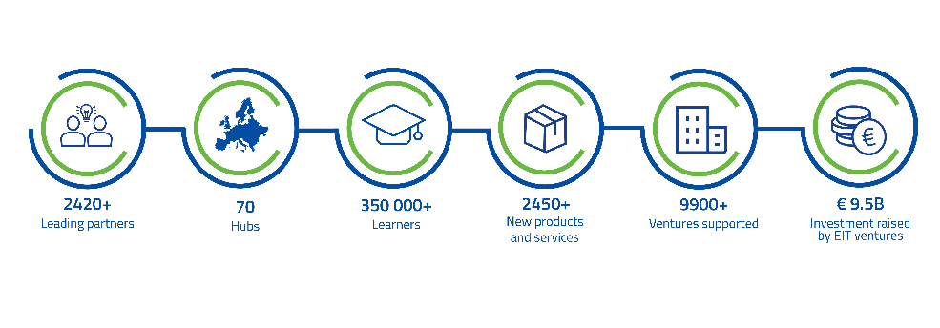

Stay TUNED FOR EIT WATER

The EIT continues to grow with its tenth Knowledge and Innovation Community (KIC) in the field of water, marine and maritime sectors and ecosystems. The new KIC will steer innovation to tackle water scarcity, droughts, floods, and marine and freshwater degradation. It will connect thematic partners to Europe’s largest innovation ecosystem, strengthening the blue economy and Europe’s competitiveness. The Call for Proposals for the new KIC will be published in 2025 and the designated EIT KIC will be launched in 2026. You can find more information related to EIT Water and the timeline here.

